
Submitted by : Spogmai Jan
Roll no : 2430 -0081
Submitted to : sir Nouman Asim
Computer networks
Lab 07
Task 01: Design a network using two switches with two LAN which have at least 2PC’s. Connect these LAN’s with two Routers. Configure the Network by using Routing Information Protocol (RIP). Get the reply (msg broadcasting) from PC0 of One LAN to others LAN any PC’s.

ROUTER 0:
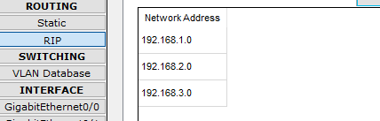
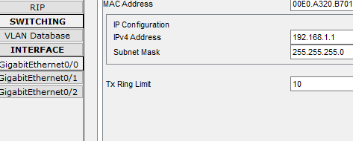
GIGABITETERNET 0/1:
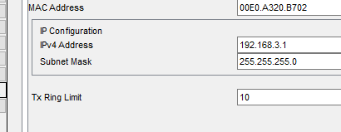

ROUTER 1:
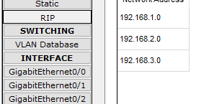
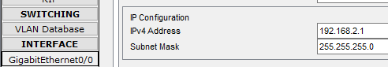

GIGABITETERNET 0/1:
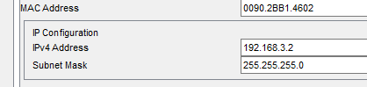
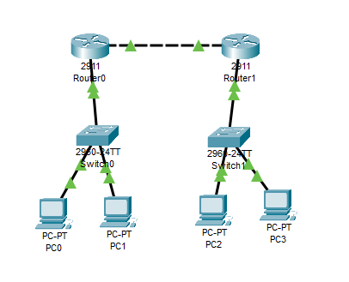
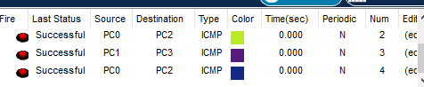
Task 02:
Create a network in which you have three Routers with 3 switches. Switches are connected as S1 with LAN A, S2 with LAN B and S3 with LAN C. It’s should be done by properly creating Routing Information Protocol (RIP). Enable LAN communication by allowing message broadcasting between the different LANs across the switches.

Router 0:
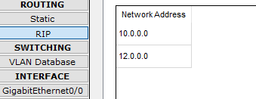
Router 1:
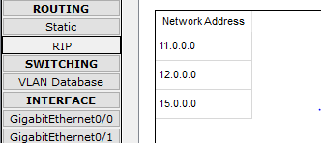
Router 2:
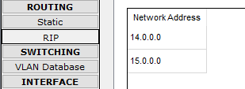

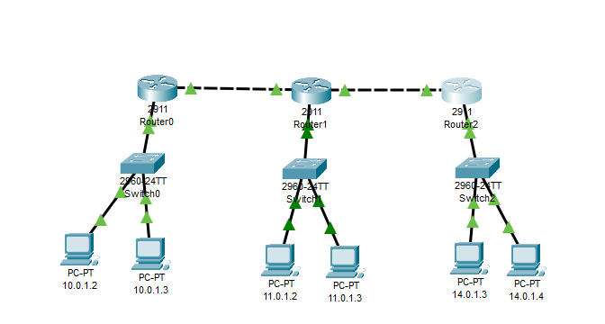

Task 03:
Design a network using 3 routers, 3 switches, and Switch 1 have LAN A and Switch 2 have LAN B and Switch 3 with LAN C. Configure the Network by using Routing Information Protocol (RIP)




